Name _________________________________________ Period ______ Date _______
Annotation
- What did a team of German and French researchers discover about the nanoparticles of tattoo ink?

- Researchers found that only 2 of the 4 inked donors presented stained lymph nodes. Would you consider this to be strong evidence?

- What 6 types of particles were found among the ink nanoparticles that could be considered “toxic?”

‘Toxic’ tattoo ink particles can travel to your lymph nodes
Video/article: https://globalnews.ca/news/3746925/tattoo-ink-safety-lymph-nodes/
By Jenny Rodrigues
Multimedia Producer Global News

Guiding Question: Are tattoos safe or are they a health risk?
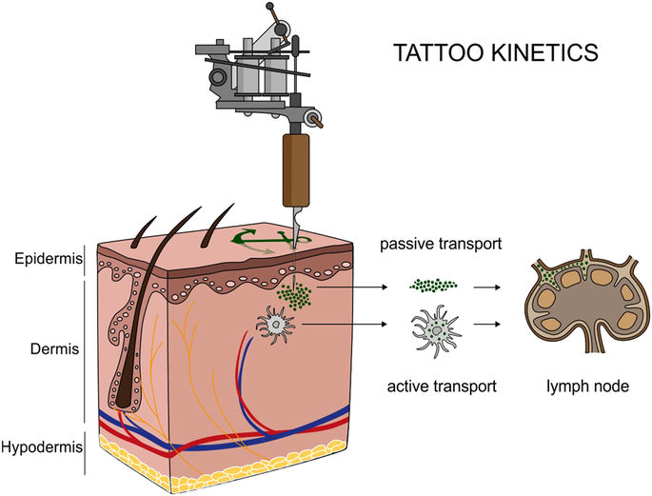
In a study published in Nature: Scientific Reports, a team of French and German researchers reported that nanoparticles found in some tattoo inks can migrate away from the skin — and accumulate in lymph nodes.
Scientists from Germany and France analyzed the bodies of 4 donors with tattoos and compared them with 2 donors without tattoos.
They found that tissue samples from 2 of the inked donors had stained lymph nodes matching the elements on the pigments on their skin.
Among the nanoparticles were five elements that they identified as “toxic,” which were aluminum, chromium, iron, nickel and copper. Additionally, the researchers found elevated levels of titanium dioxide (TiO₂) — a white tattoo ink pigment that is added to other pigments to create various color shades — in the skin and lymph nodes of tattooed donors but not in the control sample.
The tissue donors were anonymous, so the researchers did not have any health information about them. The study stopped short of suggesting that the nanoparticles can cause any adverse health effects.
But, the researchers say their findings should be taken into account for those planning on getting tattoos.
“When someone gets a tattoo, they are often very careful in choosing a parlor where they use sterile needles that haven’t been used previously,” said one of the study’s authors, Hiram Castillo. “No one checks the chemical composition of the colors, but our study shows that maybe they should.”
Some ink particles can travel to the lymph
nodes, like those under the ears.

Dr. Lisa Kellett, a Toronto-based dermatologist who has been practicing for 25 years, said the findings are not surprising, especially because it is well known that tattoo pigment can migrate (For example, when tattoos get more blurry over time because of ink migration).
Annotation
4. Why do tattoos get more blurry over time and how does this connect to nanoparticles found in the lymph nodes?

5. What is the lymphatic system’s main function?

6. According to Kellett, what are the greatest risks that come with tattoos?

“[This study] basically tells us that the tattoo ink can migrate all the way to the lymph nodes, which is absolutely not a surprise.”
Kellett explained that our bodies are programmed to try to get rid of anything foreign, which is one of the lymphatic system’s main functions.
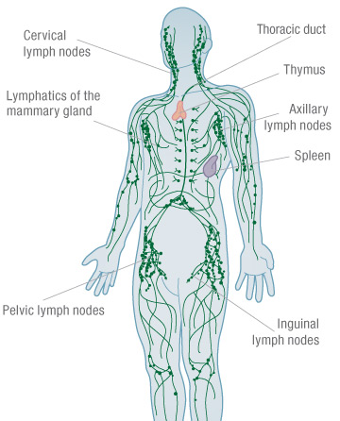
“The lymphatic system is so critical to our immune system,” she said. “When you see tattoo ink in the lymph nodes, it’s doing its job in trying to protect the human organism.”
Dr. Matthew Cheung, a hematologist who works primarily with lymphoma patients (cancer in the lymphatic system), concurred with Kellett, adding that the study sheds new light on the type, concentration and size of the particles found in the lymph nodes.
“The concern would be that we know of heavy metals at certain concentrations or certain oxidized states could be harmful. For example, they could interfere with cellular function or cause cell injury,” he said.
“They have the potential to be harmful, but we just don’t know at this level of research, at the concentrations of the particles that were found, at this point in time, whether these findings have clinical relevance.”
Kellett says the greatest risks that come with tattoos are contracting communicable or local infections or developing an allergy to the ink. But, she says the presence of pigment in your lymph nodes, in her opinion, is not going to cause major damage or injury.
“In general, the amount of ink is such a small part of your body that it’s not significant,” she said.
Annotation
7. What did Kellett further explain could be a risk when ink nanoparticles are found in the lymph nodes?

8. What is the “take-home” message with this study?

However, she cautioned that colored lymph nodes may pose an issue for doctors treating melanoma patients.
Kellett explained that lymph node pigmentation is often used as a marker for malignant melanoma patients, and tattoo ink that mimics this pigmentation may affect a patient’s diagnosis and staging.
Cheung says the take-home message from the study is that it highlights how little we know about the long-term safety of tattoos. As the U.K.’s National Health Service points out, there is very little research on the effects of tattoos on human health, due to ethical issues.
There really hasn’t been long-term studies that look at the health implications, beyond what happens in the skin,” he said. “For people thinking about getting tattoos, they should at least consider the possible risks that they’re going to go deeper than what happens in the skin.”
According to Health Canada, cosmetic pigments such as tattoo ink are not specifically approved by the government body. Instead, they maintain a “hotlist” of ingredients that are restricted or prohibited in cosmetics.
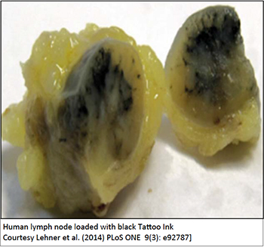
“It is the responsibility of the manufacturer or importer to meet the requirements of the Food and Drugs Act and Cosmetic Regulations, and ensure that the product they are selling is safe. The same requirements apply to tattoo inks containing nanoparticles. […] The Cosmetic Ingredient Hotlist can be referred to in order to identify ingredients (including those that impart color) that are restricted or prohibited for use in cosmetic products,” a spokesperson told Global News.
Admittedly, this is a small sample size, so these findings are far from being the final word on the matter, and this paper definitely doesn’t support some advocates’ argument that tattoo ink can cause cancer. But it does confirm that tattoo pigments can both travel in the body and accumulate in lymph nodes which could be worrisome.
“In future experiments, we will also look into the pigment and heavy metal burden of other, more distant internal organs and tissues in order to track any possible biodistribution of tattoo ink ingredients throughout the body.”

Biopsy Reference Sheet of Histology Results: Skin and Lymph Nodes
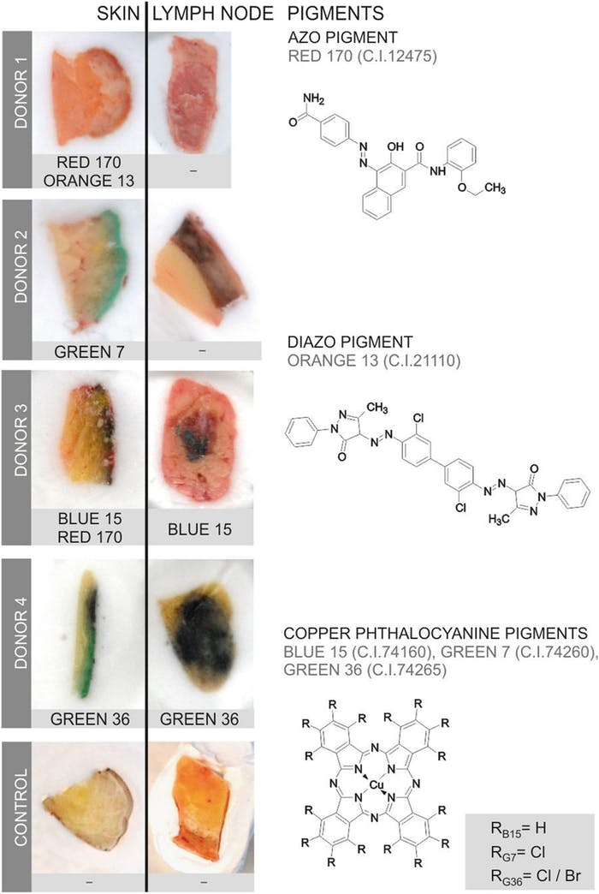
Cadaver | Tissue Sample |  | Observations: Compare the Skin to Lymph Node)  (Is ink present in the lymph tissue? What pigment color do you see?)
 | Skin | Lymph Node
Donor 1
Donor 2
Donor 3
Donor 4
Control

Body Paragraph: Four E’s
Topic Sentence
(Claim)
(Green)
The topic sentence in a paragraph conveys a claim, assertion, major detail or fact about the thesis/central idea of the entire text.
Evidence  (Red)  When integrating evidence into writing, use direct quotes or paraphrase from a primary source (a person, expert, scientist, researcher, institution, research results, statistics, data, percentages, etc.) or a secondary source to prove the claim, assertion, fact or detail.  Direct quotes: follow MLA citation  Jay Gatsby appeared to be a “man of fine breeding” (72).  Paraphrase: express the meaning of the author’s words using your own words  Jay Gatsby appears to be a man raised by an upper-class family. | Explanation  (Reasoning)  (Blue)  The explanation is typically the interpretation of the cited information (evidence), main idea (claim), or topic sentence.  Starter words include:  This means…  In fact, …  Since…  Because…  What this means is…
Example  (Purple)  The example is sharing a representation that illustrates the major detail that is being expressed in the topic sentence.  The example must be paraphrased.  Examples will require a text-self, text-text, or text-world connection.  Starter words include:  For example…  For instance… | Elaboration  (Orange)  Elaboration is the process of enhancing ideas by providing more detail for the purpose of clarification so that there is no misunderstanding of the claim. Elaboration will always connect back to the topic sentence and use a text structure.  Questions that elaboration may answer:  Why does this matter?  How does this connect to a larger claim?  How does this affect the world?  How does this affect the character/theme?

Short Response Prompt
Directions: In a well-organized paragraph, explain the author’s purpose of the text, “‘Toxic’ tattoo ink particles can travel to your lymph nodes.” Be sure to use the four E’s (evidence, explanation, example, and elaboration) as well as transitional words and phrases in your response.
Guiding Question: Are tattoos safe or are they a health risk?
Prompt | Structured Writing
Topic (Claim)
Conveys a claim, assertion, major detail or fact about the thesis/central idea of the entire text.

Evidence
When integrating evidence into writing, use direct quotes or paraphrase from a primary source or a secondary source to prove the claim, assertion, fact or detail.

Explanation
(Reasoning)
Interpretation of the cited information (evidence), main idea (claim), or topic sentence.

Example
Paraphrased example is sharing a representation that illustrates the major detail that is being expressed in the topic sentence.

Elaboration
Process of enhancing ideas by providing more detail for the purpose of clarification so that there is no misunderstanding of the claim. Elaboration will always connect back to the topic sentence and use a text structure.

Elaboration using Text Structures

Write your own text structure statement using your knowledge of “The Space-Taker Effect.”

Sequence  The author lists items or events in numerical or chronological order.  Initially…  Furthermore…  In addition… | Initially, the No Child Left Behind Act was intended to increase student motivation. In turn, previously motivated students were neglected. In the end, the legislation only strengthened the “space-taker effect.”
Compare/Contrast
The author explains how two or more things are the same or how they are different.

Although…
However…
Even though…

Cause/Effect
The author lists one or more causes and effects.

Consequently…
Due to…
Therefore…

Problem/Solution
The author states a problem then lists one or more solutions for the problem.

In order to solve…
The issue here is…
The difficult…

Short Response Template

Name:

